**Task 9 – Simple Menu Selection**

**Algorithm**

• Show a menu to the user (1 = Check Balance, 2 = Withdraw, 3 = Deposit, 4 = Exit).

• Take user input using prompt() and convert to number.

• Use switch to determine which operation to simulate.

• Use default to handle invalid input.

• Show both input and action in **console** and **alert**.

**Psudocode**

START

PROMPT user to choose an option (1–4)

CONVERT input to number

DISPLAY input in console

SWITCH on input

CASE 1: DISPLAY "Check Balance"

CASE 2: DISPLAY "Withdraw"

CASE 3: DISPLAY "Deposit"

CASE 4: DISPLAY "Exit"

DEFAULT: DISPLAY "Invalid selection"

END

**Code(javascript)  
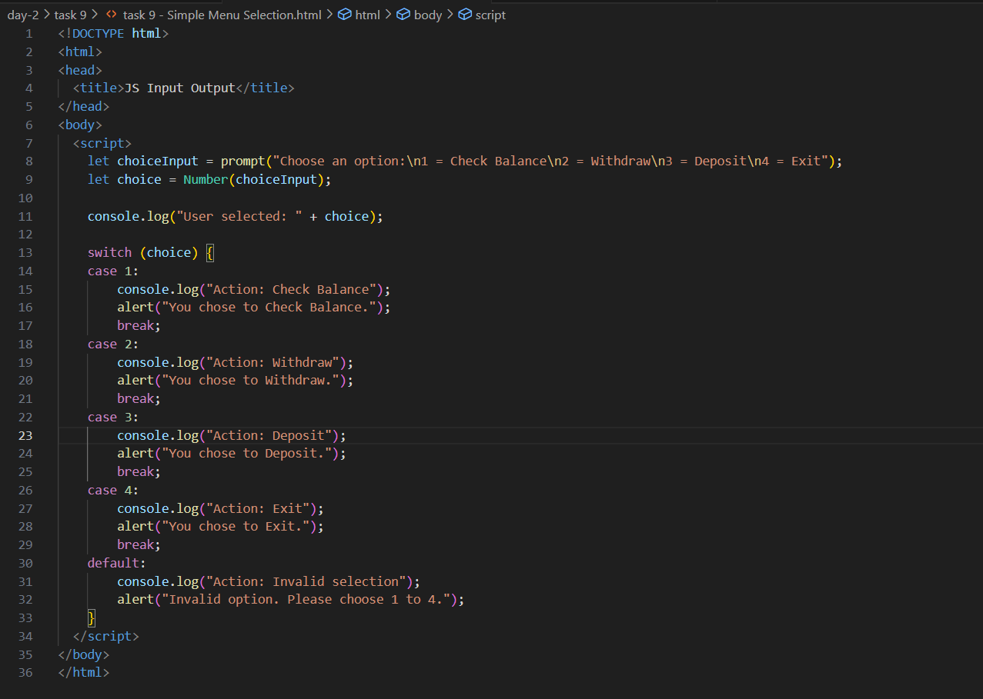**

**Output (test case 1)**

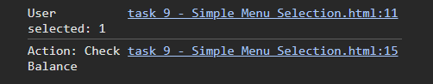  
**Output (test case 2)**

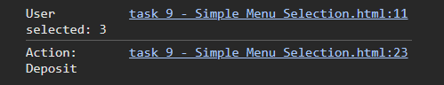  
**Output (test case 3)**

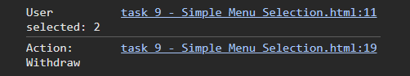

**Observations**

• Demonstrates **switch-case** for clear menu selection.

• Uses Number() to ensure numeric comparison inside switch.

• Includes a default case for user-friendly error handling.

• A good example of handling fixed options in interactive programs.